1. selecting all columns from the "employees" table.

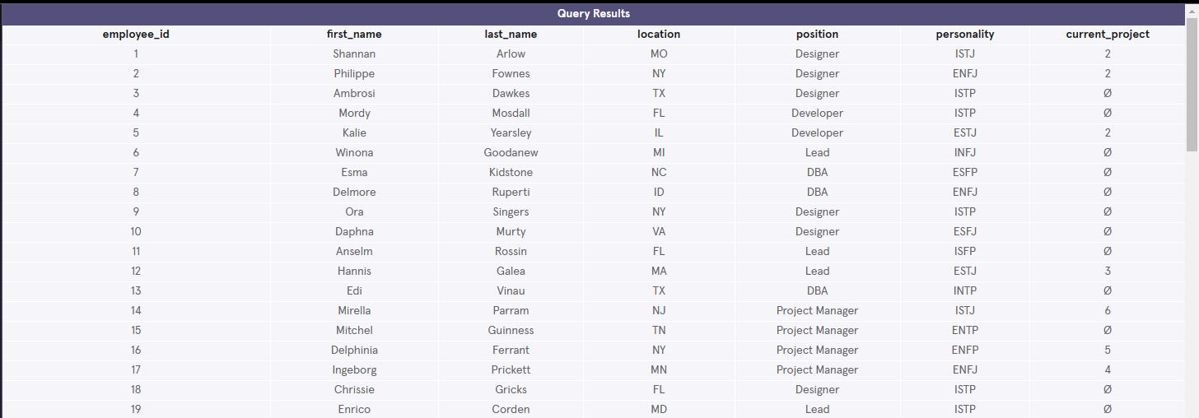

2. selecting all columns from the "projects" table.

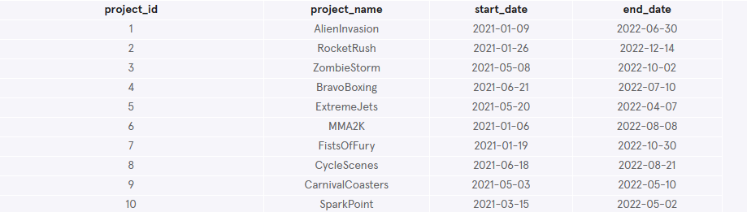

3. selecting the first and last name of employees from the "employees" table where their current project is null.

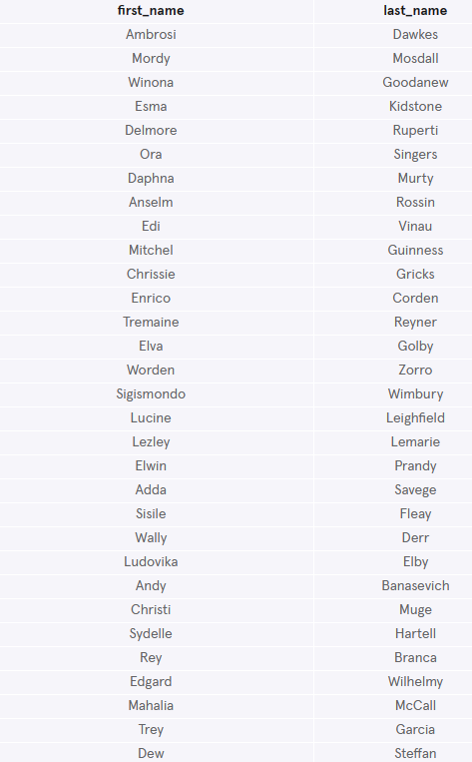

4. selecting the project name from the "projects" table where the project ID is not in the list of current projects from the "employees" table.

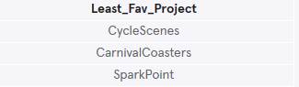

5. selecting the project name from the "projects" table that has the most employees working on it, by counting the number of employees working on each project and selecting the project with the highest count.



6. selecting the project name from the "projects" table where multiple employees are working on the same project.

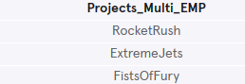

7. selecting the count of all projects multiplied by 2, minus the count of developers currently working on a project.



8. selecting the most common personality type from the "employees" table.



9. selecting the project name from the "projects" table where the employees working on it have the most common personality type.

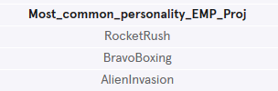

10. Finding the personality type most represented by employees with a selected project; names of those employees, the personality type, and the names of the project they’ve chosen.

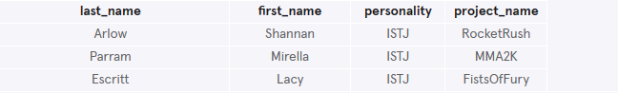

11. selecting the last name, first name, personality type, and project name from the "employees" and "projects" tables where the employees working on the project have the most common personality type. It also includes a CASE statement that counts the number of incompatible personality types based on the employee's personality type.

